# Model of Environment

# Temperature

The Basic “zero-dimensional” Energy Balance Model (EBM) for global average temperature

– Energy Input (sun)

– Energy Output (planetary radiation)

– Equilibrium: the Greenhouse Effect, climate

– Circulation

2. The one-dimensional time dependent EBM

– Response time scale

– Seasonal cycle, land and ocean

The seasonal cycle (without circulation)

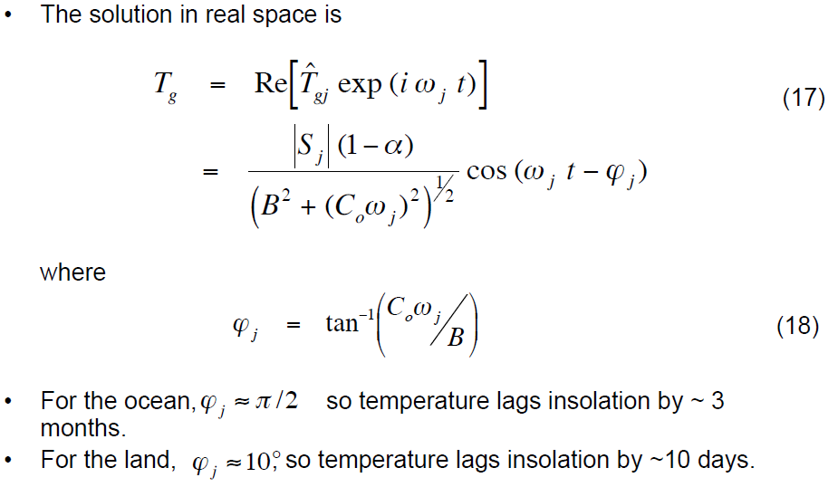

* $T_{g}$ Temperature of ground in a latitude
* $S_{j}$ Solar insolation in latitude band j(W/m2)

S is the insolation incident at a particular latitude.

$S_{0}$ = 1367W $m^{-2}$

* $α_{earth}$ = 0.30 replaced by $α_{i}$
* **B**=2.17 W m-2 oC-1
* Cx is the heat capacity, and we are ignoring circulation

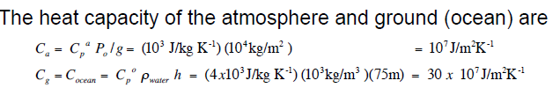

$ω_{j}$

* **t** Time

Ti = [Si(1- α i) + FTAve - A]/(B+F)

  i=1..9 regions

|  |  |
| --- | --- |
| Si | Solar Flux in Latitude Band i |
|  | This is the product of S/4 (the average global solar constant) times the insolation *s*i |
| *s*i | Solar Insolation 日照量 |
|  | The fraction of solar flux incident on each latitudinal band. |
| α i | Albedo in Latitude Band i **planetary albedo**行星反射率 |
|  | The albedo of ice is much larger than the albedo of land/water. We can do a crude model of the temperature dependence of the albedo by using α i=0.3 for Ti > Tc or α i=0.6 for Ti <= Tc |
| Tc | Below this Temperature, we assume a Permanent Ice Pack (Tc = -10oC) |
| F | Heat Transport Coefficient (F=3.80 W m-2 oC-1) |
| TAve | Global Weighted Average Temperature |
|  | This temperature is the weighted average of the temperature in all of the latitude zones on the previous iteration. The weighting factors *f*i are just the relative fraction of the surface area of the sphere in each latitude zone. |
| A & B | Coefficients expressing Infrared Radiation Loss (A=204 W m-2 and B=2.17 W m-2 oC-1) |
| CE | Heat Capacity (CE = 2.08 × 108 J/m2 oC) |

This table [from S.G. Warren & S.T. Schneider, *J. Atmos. Sci.* **36**, 1377-91 (1979)] contains some actual measurements - this may be useful in extending your models:

|  |  |  |  |  |
| --- | --- | --- | --- | --- |
| Zone | Annual Mean  Temp (oC)a  Ti | Solar Insolation  (Fraction of  Solar Constant) b  *s*i | Albedoc  α i | Heat Transfer Into/Out of  Zone (W/m2)c |
| 80-90o N | -16.9 | 0.500 | 0.589 | -103 |
| 70-80 | -12.3 | 0.531 | 0.544 | -94 |
| 60-70 | -5.1 | 0.624 | 0.452 | -72 |
| 50-60 | 2.2 | 0.770 | 0.407 | -47 |
| 40-50 | 8.8 | 0.892 | 0.357 | -21 |
| 30-40 | 16.2 | 1.021 | 0.309 | 1 |
| 20-30 | 22.9 | 1.120 | 0.272 | 18 |
| 10-20 | 26.1 | 1.189 | 0.248 | 46 |
| 0-10o N | 26.4 | 1.219 | 0.254 | 59 |
| 0-10o S | 26.1 | 1.219 | 0.241 | 56 |
| 10-20 | 24.6 | 1.189 | 0.236 | 41 |
| 20-30 | 21.4 | 1.120 | 0.251 | 22 |
| 30-40 | 16.5 | 1.021 | 0.296 | 0 |
| 40-50 | 9.9 | 0.892 | 0.358 | -27 |
| 50-60 | 2.9 | 0.770 | 0.426 | -57 |
| 60-70 | -6.9 | 0.624 | 0.513 | -86 |
| 70-80 | -29.5 | 0.531 | 0.602 | -90 |
| 80-90o S | -42.3 | 0.500 | 0.617 | -88 |

**Solar Absorbed**

– The amount of energy absorbed depends on

• the top of the atmosphere radiation 

• the distribution of insolation incident on the spherical earth

• the optical properties of the absorbers (mainly in the visible

bands, where most of the energy from the sun is emitted).

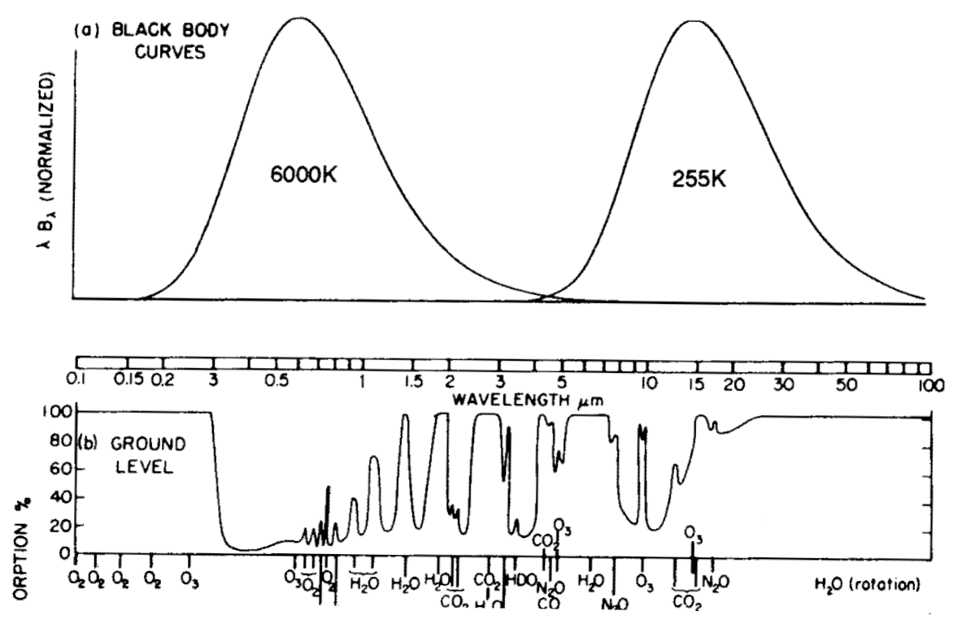

• Most of the objects that absorb visible (insolation) well are on

the surface of the planet (only a small fraction of insolation is

absorbed in the atmosphere)

The amount of energy absorbed depends on albedo α

– We will define albedo as the ratio of visible energy reflected (not used) to that incident will be called the albedo

– The average for the earth is called the planetary albedo行星反射率 $α_{earth}$ = 0.30

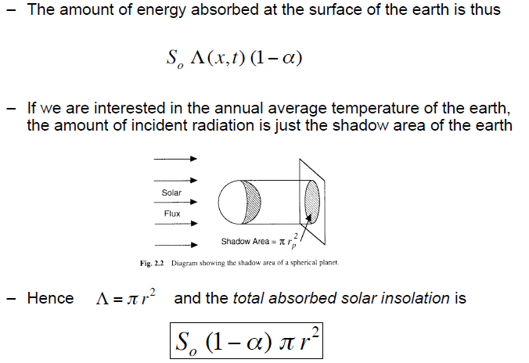

# Pressure

Using ISA standards, the defaults for pressure and temperature at sea level are 101,325 Pa and 288 K.

**Weather Conditions**  
Due to the fact that weather conditions affect pressure and altitude calculations, the pressure and temperature at sea level must be known. The altitude at a given air pressure can be calculated usingEquation 1 for an altitude up to 11 km (36,090 feet). This equation can be arranged to also calculate the air pressure at a given altitude as shown in Equation 2.

https://cdn.shopify.com/s/files/1/0964/1872/files/air-pressure-altitude-calculator_clip_image004.png

**where,**  
  
https://cdn.shopify.com/s/files/1/0964/1872/files/air-pressure-altitude-calculator_clip_image006.png = static pressure (pressure at sea level) [Pa]  
https://cdn.shopify.com/s/files/1/0964/1872/files/air-pressure-altitude-calculator_clip_image008.png = standard temperature (temperature at sea level) [K]  
https://cdn.shopify.com/s/files/1/0964/1872/files/air-pressure-altitude-calculator_clip_image010.png = standard temperature lapse rate [K/m] = -0.0065 [K/m]  
https://cdn.shopify.com/s/files/1/0964/1872/files/air-pressure-altitude-calculator_clip_image012.png = height about sea level [m]  
https://cdn.shopify.com/s/files/1/0964/1872/files/air-pressure-altitude-calculator_clip_image014.png = height at the bottom of atmospheric layer [m]  
https://cdn.shopify.com/s/files/1/0964/1872/files/air-pressure-altitude-calculator_clip_image016.png = universal gas constant = 8.31432 https://cdn.shopify.com/s/files/1/0964/1872/files/air-pressure-altitude-calculator_clip_image018.png   
https://cdn.shopify.com/s/files/1/0964/1872/files/air-pressure-altitude-calculator_clip_image020.png = gravitational acceleration constant = 9.80665https://cdn.shopify.com/s/files/1/0964/1872/files/air-pressure-altitude-calculator_clip_image022.png   
https://cdn.shopify.com/s/files/1/0964/1872/files/air-pressure-altitude-calculator_clip_image024.png = molar mass of Earth’s air = 0.0289644 [kg/mol]

In the International Standard Atmosphere (ISA) the Mean Sea Level (MSL) temperature is +15oC and decreases by 2oC for every 1,000 ft gained in altitude. ISA MSL is another way of saying “pressure height zero”

# Relative Humidity

Relative humidity is the ratio of two pressures: %RH = 100 x p/ ps

where p is the actual partial pressure of the water vapor present in the ambient and ps the saturation pressure of water at the temperature of the ambient.

p = partial pressure of water vapor [Pa]

**Vapor Pressure of Water**

The vapor pressure of water, or saturation vapor pressure, increases strongly with increasing temperature:

|  |  |
| --- | --- |
| Temperature  (°C) | Water Vapor Pressure  (kPa) |
| 0 | 0.61 |
| 10 | 1.23 |
| 20 | 2.34 |
| 30 | 4.24 |
| 40 | 7.37 |
| 50 | 12.33 |
| 60 | 19.92 |
| 70 | 31.18 |
| 80 | 47.34 |
| 90 | 70.11 |
| 100 | 101.33 = 1 atm |

**Vapor Pressure Above Ice**

|  |  |  |  |
| --- | --- | --- | --- |
| Temp  (°C) | Vapor Pressure  Liquid (kPa) | Vapor Pressure  Ice (kPa) | Ratio Ice/Liq. |
| 0 | 0.611 | 0.611 | 1.00 |
| -5 | 0.422 | 0.402 | 0.95 |
| -10 | 0.287 | 0.260 | 0.91 |
| -15 | 0.191 | 0.165 | 0.86 |
| -20 | 0.126 | 0.103 | 0.82 |
| -25 | 0.081 | 0.064 | 0.78 |
| -30 | 0.049 | 0.037 | 0.75 |